**Level Up: SSBM Subtleties**

Teching, DI’ing, WaveDashing and more...

**Introduction:**

Super Smash Bros. Melee was one of the first releases on the Nintendo GameCube. Developed by Hal Laboratory, with Mashiro Sakura as the head of production, SSBM would serve as the follow-up to the original Super Smash Bros (Smash 64) game released in 1999. Players who grew up on the original Super Smash Bros. could experience the game as never before, with updated graphics, new and more complex stages and a plethora of new characters to choose from. HAL Laboratory developers highlighted all of this, especially the massive advancements to the graphics, in the well-known, now classic opening scene. Fifteen years later, SSBM remains wildly popular, particularly on the tournament scene.

Although the Smash 64 and SSBM share the same underlying idea and interface, the advancements to SSBM make it an entirely different game. Players now may choose from 25 characters instead of 8. Smash 64 focused on hits and combos, similar to other traditional fighting games. Melee emphasized speed and accurate movements that allowed users to create quick, damage-heavy combinations. Competitive SSBM players use these combinations, as well as exploiting unintended glitches in the game, to create an incredibly fast-paced one-on-one fighting game.

In this guide we will introduce to you several of these in-game manipulations. These actions take advantage of the game’s code to give players a distinct edge against opponents. Some characters are more heavily favored by the game’s glitches, but there are several tactics that all characters can use. These include L-cancelling, DI’ing, WaveDashing, Dash-Dancing, and more. It is important to note that not all of these tactics are exploitations of software glitches. Some are side effects of other features deemed unimportant by developers, and others are nuanced techniques that aren’t typically noticed by novice players. Applying these tactics to your gameplay makes playing SSBM and entirely new experience, so let’s get down to it…

**Controller Overview:**

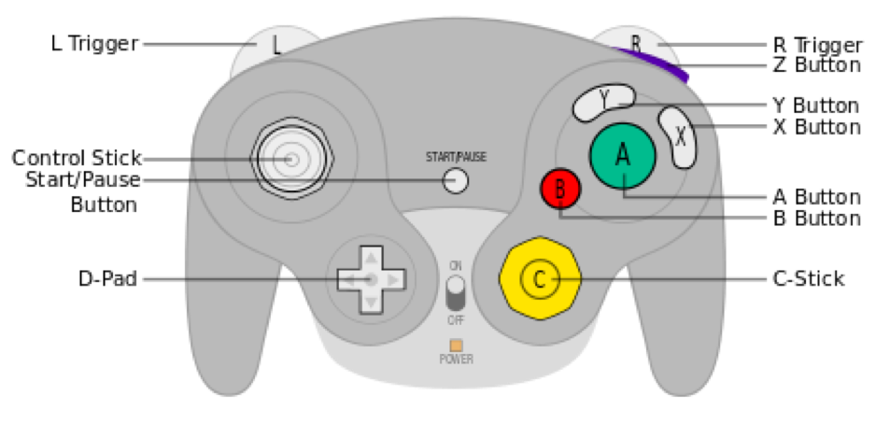

**Figure 1: Game Cube Controller**

Though you’re no doubt already familiar with the GameCube controller, it never hurts to have a guide to come back to, especially with some of the more nuanced and complex moves that will be introduced. [Figure 1](https://nikkiwines.github.io/TPAA/TPAA-2.html#1), and [Table 1](https://nikkiwines.github.io/TPAA/TPAA-2.html#t1) are for you to reference

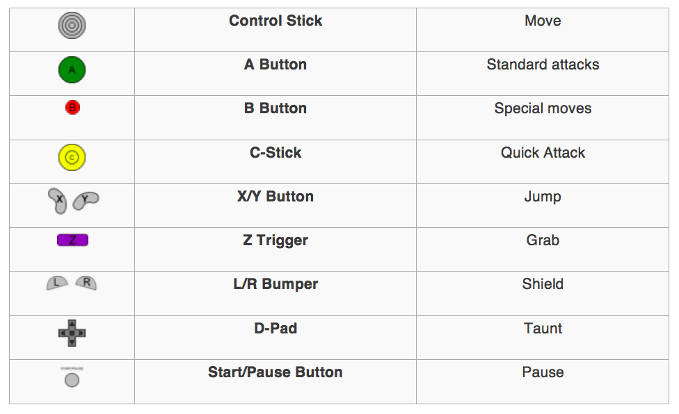

**Table 1: Controller Features and Actions**

Keep in mind that the moves that will be described below will use features in the GameCube controller in ways that you likely haven’t used before. It never hurts to be familiar with the controller! If you’d like a review of the basics, check out our first guide “Super Smash Bros. Melee 101”.

**Step 1: DI'ing**

DI stands for Directional Influence. When your character is hit with a powerful attack, it flies for a certain distance across the stage. DI’ing influences how your character absorbs the attack. DI’ing alters your character’s flight path, although it cannot completely change where your character goes. Essentially, DI’ing reduces the distance that your character travels when hit.

There are three types of DI: trajectory DI (standard), Smash DI, and Automatic Smash DI:

***Trajectory DI:***To minimize your flight path, aim your Control Stick in a generally perpendicular direction to the direction from which you were hit. If you were hit from the left, for example, you should begin your DI by tilting in an upward or downward direction. From there, as you move across the stage, you should tilt more toward where you flew from, i.e. tilting your Control Stick back toward your opponent. Figure 2.1 shows how DI'ing in different directions affects your flight path.

***Smash DI:***This technique allows you to slightly change your position during the freeze frames that occur after an attack. During these freeze frames, the Control Stick should be tilted to move the character slightly out of the way of the attack, sparing it some damage. Figure 2.2 shows a player using Smash DI in combat. Repeatedly tapping the Control Stick, rather than just tilting it, will cause the character to move further.

***Automatic Smash DI:***This is a weaker version of smash DI. In automatic smash DI, after the freeze frames the character will move slightly in whatever direction the Control Stick is tilted. Tilting the C-stick in a direction will override the Control Stick’s tilt, and allow the character to DI simultaneously in a different direction.



**Figure 2.1: Direction Influence Trajectories** 

**Figure 2.2: Smash DI Combat Example**

**Step 2: L-Cancelling**

Although it may seem unimportant, each attack and action has a recovery time. At higher levels of gameplay, your opponent will take advantage of any moment where you’re incapacitated, so cutting down on recovery time is crucial. L-cancelling causes the game to play the standard landing animation, rather than an aerial attack’s longer landing animation, cutting down on the recovery of a player.

To L-cancel you must shield within 11 frames of landing a jump or fall. You can shield with either the “L” or “R” bumper. You should also be tilting down on your Control Stick to fast-fall, decreasing the time you’re vulnerable in the air. “Within 11 frames” may seem like a very specific period of time, but it really just means that you should be briefly shielding right before you land. You can also L-cancel by pressing the Z trigger.

Note: You can only L-cancel regular in-air attacks. Special aerial moves have their own lag time that cannot be L-cancelled. Figure 3, below, shows the direct impact of L-cancelling on recovery time.



**Figure 3: Link Without vs. With L-Cancelling Recovery Time**

**Step 3: Teching and Tech-Chasing**

When your character is hit with an attack, it flies uncontrollably through the air before it recovers. Teching is the act of shielding directly before landing (within 20 frames), causing your character to tumble out of the fall. Like L-cancelling, teching uses shielding and landing techniques. It also minimizes recovery time. Instead on landing on the ground and having to wait for the recovery period after a fall, your character “techs” into an upright stance, allowing it to counter-attack much more quickly. Techs can also be performed against walls and ceilings. Figure 4.1 shows Fox teching against a wall on the stage "Corneria". Standard techs occur by simply pressing the shield briefly directly before landing, allowing a character brief invincibility and causing it to bounce upright

Rolling techs use the Control Stick as well as shielding. When the character is about to hit the ground, shielding briefly and tilting in the direction that the character was moving allows your character to roll out of the hit, shown in Figure 4.2. This technique allows your character to land upright and farther from their attacker.

Tech-Chasing is the art of predicting an opponent’s tech and attacking them before they can respond. Though teching grants players a brief period of invincibility, it also introduces a couple of windows of vulnerability, specifically right before the end of the tech. Striking in this period of vulnerability (when your opponent also has no control over their character, considering that it is in mid-tech), allows for damage-racking combos and increased control over your opponent. Tech-chasing is easiest with fast characters or characters with long-range attacks. An intense tech-chasing battle between Captain Falcon (who is chasing) and Fox is shown in Figure 4.3.

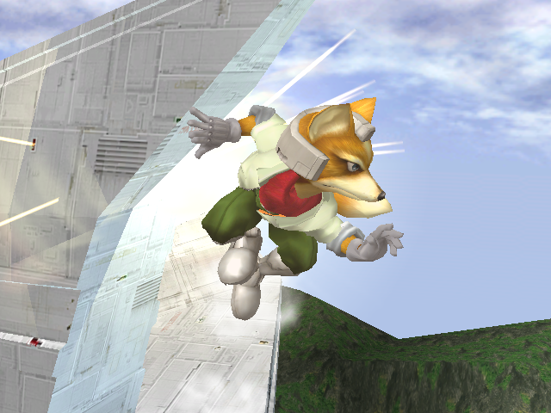

**Figure 4.1: Fox Teching against Wall**



**Figure 4.2: Right Rolling Tech**



**Figure 4.3: Tech Chasing Combat Example**

**Step 4: Dash Dancing**

Dash Dancing involves rapid, repeated left and right tapping of the Control Stick. The tapping causes the character to perform its dashing animation continuously back and forth. Each animation overrides the previous one, allowing the character to dash dance incredibly quickly. Initially this may seem useless, but dash dancing is frequently employed by expert players. Rather than an active attack, dash-dancing is more of a passive, evasive maneuver.

Although watching your character dash briefly left and right repeatedly may look funny, it actually introduces a wide variation in where your character is perceived to be. It is much more difficult to land a blow on a character that is dash dancing because its location is so ambiguous. In Figure 5 Fox displays a frame perfection dash dance. It is not necessary to get your dash dance to a frame perfect level to accurately use dash dancing.



**Figure 5: Fox Frame Perfect Dash Dance**

**Step 5: Wave Dashing**

Wavedashing is a dodging technique that manipulates the SSBM game physics to cause your character to dodge and slide slightly across the floor of the stage. Game designers were unaware of wavedashing when creating the game. Because of this, wavedashing essentially takes advantage of glitches in the game software.

To wavedash, one must air-dodge diagonally into the ground. This technique can only be performed by short-hopping into the air, then immediately air-dodging diagonally downwards. In an ideal wavedash, the jumping animation doesn’t even render. It will appear as if the character is surrounded by smoke, then slides (not dashes) in the direction of the wavedash.

Some characters have more dramatic wavedashes than others. Figure 6.1 shows the difference in length between Luigi and Peach's wavedashes. It is not necessarily better to have a longer wavedash, and each player must adapt to the length of a character's wavedash to use it effectively.

Wavedashing is used frequently in higher level SSBM play, primarily to move the character out of range of an attack’s hitbox and to adjust spacing. Wavedashing can also be extended to Fox and Falco’s “waveshine” movement, which is wavedashing out of their “B”+ Down tilt attack, called a “shine”. This move is shown in Figure 6.2.



**Figure 6.1: Length Difference in Luigi vs. Peach WaveDash**



**Figure 6.2: Fox Waveshine Example**

**Conclusion:**

This guide introduces some of the most common techniques in expert level SSBM play. As you may have noticed, the vast majority are defensive, focusing on evasive maneuvers. Although there are additional offensive techniques, the ones described above are among the first typically learned when advancing gameplay.

As with our first guide, this is not a comprehensive manual of advanced techniques used for Super Smash Bros. Melee. At this point practice is your friend, and here we shall introduce two brief types of gameplay for you to practice. First is neutral game. Neutral game involves having all of your moves readily available and is typically practiced by playing against other players. Secondary is punish game. Punish game involves moves that are only readily available after combos and attacks. This type of game is typically practiced with high-level coms whom you can configure to dodge and attack in certain manners. A good device for practicing punish game is the action platform 20xx, which offers extensive configuration abilities. In 20xx, you can set gameplay to unique specifications that allow you to practice skills like recovering adeptly from combo attacks that are otherwise very difficult to practice in normal gameplay.

We hope you’ve enjoyed this guide and that you are significantly more informed on how to begin your journey into advanced SSBM techniques. As always, practice is your friend. Finally, we leave you with this gif, which shows how integrating these techniques into your gameplay can make you much more difficult to beat!

**Thanks for reading, and happy gaming!**